**Queer Signaling in Google Maps Reviews of Spaces Marked**

**“LGBTQ Friendly” in DC**

**Marilyn Harbert**

**1. Introduction**

When a technology company like Google introduces a feature claiming to serve a marginalized community such as the LGBTQ+ community, questions should arise as to whether that is happening, and what experiences the marginalized community is having. That is the case with Google’s “LGBTQ+ friendly” label for Google Maps businesses.

In this paper I examine the LGBTQ+ label, and reviews discussing the queerness of businesses with that label. I do so through inductive coding of the reviews, and then examining what the reviews say, as well as what they do not and the possibilities of what queer experiences may be being left out. I end with a discussion of how the ambiguity of the LGBTQ+ friendly label may serve the queer community, and how non-empirical interpretations of queer speech may bring us closer to understanding the queer experiences in these places.

The contribution of this paper is to open up investigation into the LGBTQ+ friendly label and expand the possibilities for research on queer experiences finding physical spaces online and leaving signals about space online. I also show that the label has not replaced queer speech about these businesses, at least not entirely, and thus that there is still some information needs of LGBTQ+ people being attended to by leaving further reviews giving information beyond the LGBTQ+ friendly label.

**2. Background**

On Google Maps, under the list of a business’s features, there is an optional label called “LGBTQ+ friendly”. The label includes a small heart next to it with a LGBTQ+ flag filling up the heart, as shown in figure 1 below.

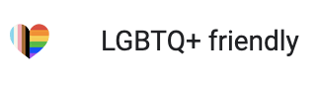

Figure 1. LGBTQ+ friendly label

Google announced that they were adding this feature, along with a “Transgender Safe Space” label in a blog post in June of 2018 (Dijk 2018). In this post they discuss the feelings someone might have in a queer space: “There’s little that compares to the feeling of walking into a place and being immediately comfortable—your shoulders loosen, your breathing slows, you physically relax, knowing you can be yourself.” (Dijk 2018). Additionally, they mention that finding spaces that evoke those feelings can be hard for LGBTQ+ people, and knowing that, they “want to help celebrate those spaces of belonging and make them easier to find” (Dijk 2018). Google claims that one way to do this is by allowing business owners to label their own businesses as “LGBTQ-friendly” (the “+” was likely added later) (Dijk 2018). They add an example of a business owner who says that he “added the LGBTQ-friendly attribute to his listing on Google to “let it be known that all are welcome without any questions” (Dijk 2018).

While attempting to explain why Google added the “LGBTQ+ friendly” label, this post raises several questions about this label. What kind of space does Google imagine will have this label, and what kind of business has this label in reality? Where in the range of queer space to queer tolerant space do these fall? Do queer patrons agree with the label of LGBTQ+ friendly for these spaces? Does this label encourage or discourage online conversation about the queerness of spaces? What does this label capture, and what does it fail to capture that is of interest to queer people?

To start to answer these questions, in this paper I examine two research questions:

**What do people say in Google Maps reviews about queer experiences at businesses labeled “LGBTQ+ Friendly” in DC?**

**How does their speech about the queerness of places reviewed interact with the Google Maps “LGBTQ+ Friendly” label, and how should we view this label?**

**Queer Signaling about Places**

There is a long history of queer people covertly and directly signaling to other queer people that spaces are tolerant of queer people or for queer people. Part of this is because of queer people were prevented from having the private lives they wanted and thus had to meet in public spaces, mixing the “public” and “private” (Springate 2016). While some of these spaces have been obvious about their queerness, others have hidden it, making it difficult for even some queer people to locate them (Hammers 2009). And as the gayborhoods have dispersed across the country, and in DC from Dupont to the rest of the city, “gay friendly” businesses have emerged around the city (Ghaziani 2016), making them more difficult to locate in some cases. In all cases, signaling about place has varied over the years. In some cases this has taken the form of publications, by and for queer people, such as magazines and newsletters (Knopp and Brown 2021). Travel guides like the Address Book and the Damron played an important role as well (Knopp and Brown 2021). Other signals take symbolic forms like queer flags hung from businesses and homes (Spruce 2024). And some, like the Google Maps “LGBTQ+ friendly” label, are by businesses meant for queer consumers (Oakenfull and Greenlee 2005).

**3. Methods**

For this study, a sample of businesses with the LGBTQ+ label were selected to examine their reviews, and inductively code those reviews for common themes or terms. Following the coding, the themes will be analyzed and discussed, and descriptive statistics for the codes will be discussed.

**Sampling and Data Collection**

For this study, a sample of five businesses was chosen from each of five categories of types of business to examine the reviews from, except in cases where less than 5 businesses could be identified with the label in that category in DC. The categories of businesses are: hair salons, bookstores, bars, clothing stores, and coffee shops. These categories were chosen to look at a wide range of types of businesses.

These businesses were found by searching on Google maps for “[category] LGBTQ+ friendly” and identifying businesses with the LGBTQ+ friendly label in the search results (as not all results had the label). In total, 22 businesses were chosen, with five bars, three bookstores, three clothing stores, five coffee shops, and five hair salons.

The reviews were copied individually from the Google Maps site for each business to a spreadsheet.

Once collected, R code was written to filter the reviews for queer terms to identify the most relevant reviews to code. The terms used were: queer, lesbian, trans, butch, masc, LGBTQ, gay, drag, homo, cis, and bi. These terms were compiled from a combination of relevant terms from Stonewall’s List of LGBTQ+ terms (“List of LGBTQ+ Terms” 2020), and adding terms noted in the initial review of the data and subtracting terms likely not to be seen.

After filtering for the terms, the data was reviewed by hand to ensure relevance, and remove reviews that did not use the terms as queer terms.

**Coding**

Following data collection, the data was coded for relevant themes. In order to create the codes, an initial read of the data was done in order to identify relevant themes to create the codes. Once the codes were created, another read of the data was done to code each review.

The codes are as follows, with an explanation of each:

| **Code** | **Explanation** |
| --- | --- |
| Identifies it as a queer place | The review directly identifies the business as a LGBTQ+ or queer place, not just a LGBTQ+ friendly place. |
| Drag show | The review mentions a drag show. |
| Positive Review | The review mentions positive aspects of their experience with the business. |
| Negative Review | The review mentions negative aspects of their experience with the business. |
| Specific type of the LGBTQ+ community mentioned | The review mentions a specific type or subset of the LGBTQ+ community. |
| Class | The review discusses class in some way, beyond a complaint on prices. |
| Race | The review discusses race in some way. |
| Racism | The review explicitly mentions an experience of racism at the business. |
| Exclusionary to some LGBTQ+ people | The review suggests that the business is exclusionary to some subset of LGBTQ+ people |
| “LGBTQ+ friendly” or “LGBT friendly” or mentions google label | The review mentions that the business is “LGBTQ+ friendly” or “LGBTQ friendly” or directly mentions the Google Maps label. |
| "diverse" | The review uses the word “diverse” or a similar term to describe the crowd at the business. |
| queer books | The review discusses queer books. |
| queer owned | The review claims that the business is queer owned. |
| homophobia | The review suggests that an incident of homophobia was experienced at the business. |
| straight | The review mentions straight people explicitly. |
| sexism | The review suggests that an incident of sexism was experienced at the business. |
| tourist/non-DC resident | The review directly identifies that the reviewer is not from Washington DC. |

**Data Analysis**

To conduct the data analysis descriptive statistics were computed in both R and excel. This was a single coder process, so no inter-coder reliability was computed.

**4. Results**

**Overview**

Only 194 reviews were coded out of the 2412 reviews originally identified for all businesses. None of the hair salons or clothing stores has reviews that were identified as relevant after filtering for queer terms and relevance. The full sums of the number of reviews identified aligning with each code are shown in the table below.

| **Code** | **N** |
| --- | --- |
| identifies it as a queer place | 85 |
| Drag show | 65 |
| Positive Review | 158 |
| Negative Review | 55 |
| Specific type of the LGBTQ+ community mentioned | 21 |
| Class | 5 |
| Race | 10 |
| Racism | 7 |
| Exclusionary to some LGBTQ+ people | 13 |
| “LGBTQ+ friendly” or “LGBT friendly” or mentions google label | 6 |
| "diverse" | 3 |
| queer books | 3 |
| queer owned | 3 |
| homophobia | 3 |
| straight | 6 |
| sexism | 2 |
| tourist/non-DC resident | 6 |

**Categories**

The table below breaks down the number of reviews that fell into each code by type of business.

| **Type** | **identifies it as a queer place** | **drag show** | **positive review** | **negative review** |
| --- | --- | --- | --- | --- |
| bar | 72 | 64 | 137 | 53 |
| bookstore | 0 | 0 | 5 | 0 |
| coffee shop | 13 | 1 | 16 | 2 |

| **Type** | **Specific type of LGBTQ community mentioned** | **class** | **race** | **racism** |
| --- | --- | --- | --- | --- |
| bar | 21 | 5 | 10 | 7 |
| bookstore | 0 | 0 | 0 | 0 |
| coffee shop | 0 | 0 | 0 | 0 |

| **Type** | **exclusionary to some gays** | **“LGBTQ+ friendly” or “LGBT friendly” or mentions google label** | **"diverse" crowd** | **queer books** |
| --- | --- | --- | --- | --- |
| bar | 13 | 4 | 3 | 0 |
| bookstore | 0 | 0 | 0 | 2 |
| coffee shop | 0 | 2 | 0 | 1 |

| **Type** | **queer owned** | **homophobia** | **straight** | **sexism** | **tourist/not DC resident** |
| --- | --- | --- | --- | --- | --- |
| bar | 2 | 3 | 6 | 2 | 6 |
| bookstore | 1 | 0 | 0 | 0 | 0 |
| coffee shop | 0 | 0 | 0 | 0 | 0 |

Most of the reviews that were coded were reviews for bars; without counting the bars, only 23 reviews were on the coffee shops and the bookstores.

**5. Discussion**

The results of this study open up a variety of possibilities for analysis, and not all will be discussed in this paper. The primary conclusion of this analysis is to expand the realm of possibilities for research on how queer people find physical spaces online, how businesses advertise themselves to queer people online, and how internet companies like Google and their technologies act as intermediaries in cases of queer searches for place. Thus in the discussion of each facet of the study, the possibilities for what might be happening are discussed.

Additionally by discussing the possible, I open up consideration for a larger range of experiences than may be able to be captured by traditional methods. I do so in inspiration from Saidiya Hartman’s Wayward Lives and how her speculative fiction forces us to consider the perspective and lives of wayward black women in history, and grapple with the limits of the archive and the power dynamics in who gets recorded and how (Hartman 2019). By doing so she “elaborates, augments, transposes, and breaks open archival documents” so that we can see a “richer picture” of black life in the 20th century (Hartman 2019).

While my work may not be as powerful as Hartman’s, I would like to speculate to force us to consider experiences and possibilities beyond the label provided by Google and the decision by a business owner to label their own business LGBTQ+ friendly. I seek to move beyond the narrowing of experience and perspective that label suggests towards a consideration of multifaceted queerness, with a spectrum of queer spaces and intersectional identities. Most importantly I want to center the experiences of queer people, which the label does not do as it is created by Google and chosen by business owners. By centering reviews and the possibilities beyond those reviews, we can start to see where power is in the labeling and who and how these labels serve communities, and what alternate signaling might serve queer people best.

**Existence of Queer Speech**

One possibility with the introduction of the LGBTQ+ friendly label was that queer people would see the label on a business, and decide not to leave a review about the business’s queerness because the label already signaled to other queer people that the business was LGBTQ+ friendly, and thus there would be no need to leave a review. This appears to not be the case, given the presence of 194 reviews related to queerness. However, this may be more nuanced than just that. It may be that queer speech reduced after the label was introduced, as some people felt it was redundant, while others did not. Or it may have reduced more for spaces where queerness was less salient, such as the hair salons and clothing stores, where there were no reviews related to queerness.

**“LGBTQ+ friendly” label**

Only six reviews mentioned wording similar to the Google LGBTQ+ friendly label, and none directly mentioned that they were discussing the label as shown on Google Maps. Thus it is possible that none of the reviews meant to engage with the Google Maps label. In that case there would be a disconnect between the label and the signaling of queer people. It is also possible that all six reviews were trying to directly reference the label. In which case it would suggest at least some interest in providing additional details or contradiction of the Google Maps label. It would suggest that the experiences of queer people may not be fully captured by the label and that there is a desire to engage in dialogue to add other details deemed important for other queer people to understand.

**Lack of Queer Speech for Hair Salons and Clothing Stores**

No reviews were found that use the queer terms chosen for the hair salons or clothing stores chosen to look at. This may be a matter of the small sample size of reviews. There were 337 reviews for hair salons, and only 30 reviews for clothing stores, out of 2412 total reviews. It may also be that queerness is less salient to people as an identity feature in hair salons and clothing stores, and thus they feel less driven to review and comment on it. Maybe the businesses are mislabeled, and they are not actually LGBTQ+ friendly spaces. Or maybe they are LGBTQ+ friendly, but just that; tolerant on the scale of queer tolerant to queer space. If that was the case, it may mean that queer people at these businesses would not be having the experience Google suggests “feeling of walking into a place and being immediately comfortable” and simply do not note the fact that the place is tolerant towards them, and thus they may not feel the need to comment on it.

**Multifaceted Queer Experience vs One-Dimensional Label “Queer Friendly”**

A map of DC’s queer bars printed in the gay newspaper “The Washington Blade” in 1997 (Figure 3) shows a key (Figure 2) with 20 additional aspects of queer bars by which they are categorized, from “mostly black” to “leather/levi”, “mostly men”, and “mostly women” (*The Washington Blade* 1997). This list of additional aspects suggests that queer people are interested in aspects of queer spaces beyond just the “queer” label.

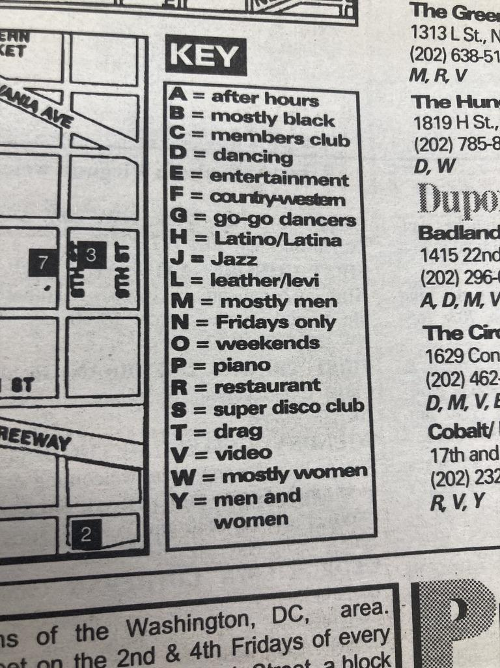

Figure 2. Key for The Washington Blade Bar Guide Map

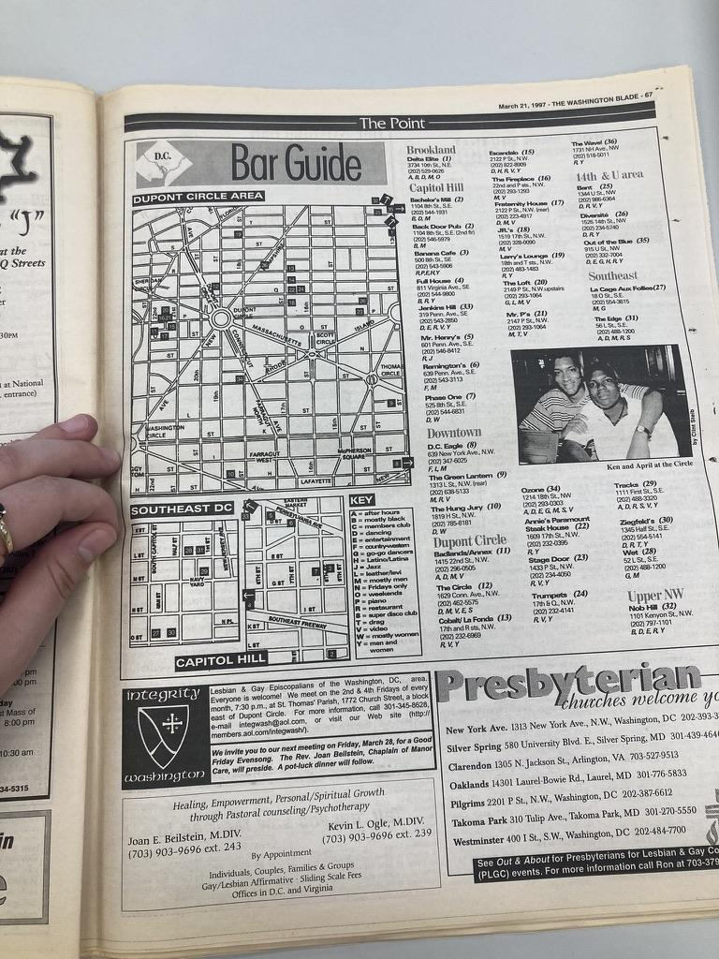

Figure 3. The Washington Blade Bar Guide Map

In contrast to the multidimensional key of the Washington Blade Bar Guide Map, the Google Maps “LGBTQ+ friendly” label is one-dimensional. It proclaims queer friendliness, the absence of which does not mean the space is not queer friendly, simply that the label has not been applied. The information transmitted by the label is very limited, although users might read more into the label than the single dimension. In the absence of more information about the “queerness” of these places, queer people may read “LGBTQ+ friendly” and assume the label is consumer chosen or chosen by Google (it is not immediately clear how the label is determined on a business page). They may also assume that “LGBTQ+ friendly” stands in as a euphemism for the business being a queer space. As I speculate about the experiences of queer people with this label and queer businesses, they may also speculate about the queerness of these spaces given the lack of information they have.

Additionally, the variety of themes covered in reviews exploring queerness suggest that there is a desire to share more details about the multiple dimensions of queerness that the LGBTQ+ friendly label does not capture.

First, not all reviews directly identified the businesses as queer places; some did not identify them at all, and some identified them as queer friendly, and only 85 identified the businesses as queer spaces.

Reviews covered many aspects, including whether queer books were present at the business, whether it was queer owned, and reviews of the drag shows, especially at the gay bars. They also discussed the multifaceted LGBTQ+ community, with discussions of race (10), class (5), and other subsets of the LGBTQ+ community (21). Not all reviews were from DC residents as well (6), which may factor into how they are interpreted by DC queer residents, and their perspective as non-locals reviewing businesses.

While many reviews were positive (158), some were negative (55). They discussed experiences of racism (7), homophobia (3), sexism (2) and other types of exclusion towards some subset of the LGBTQ+ community (13). Specific incidents discussed in the negative reviews particularly shed light on why the label LGBTQ+ friendly might not capture the experiences of all queer people.

One reviewer discusses an unwanted pat down by security guards at a bar driven by racism saying:

“I'm not very happy with how they treat people of color. Last night they tried to pat me down but let 3 white women in without a pat down. My outfit was skin tight, the heck am I hiding on my person, homes???”

Another review says only:

“As a Black queer person, this has never felt like a safe space for me.”

And another vehemently rejects the racism they experienced at this business:

“"They put dusty on my TAB receipt. RACIST GAY WHITE QUEENS. I WILL NEVER GO THERE AGAIN.”

The experiences of the above reviewers with racism at these “LGBTQ+ friendly” businesses suggests that LGBTQ+ friendly may not mean friendly to all with queer identities. This label may ignore the racism or sexism that many queer people experience in places that are friendly to some queer people, but not to all.

**Poetry, and capturing an element of queer signaling beyond just information**

In his 2006 essay “Closing Time” Shane Vogel opens with “Rumor has it that Langston Hughes was gay.” (Vogel 2006). His essay goes on to grapple with the role of historians and himself in judging the queerness of Langston Hughes (Vogel 2006). Vogel writes that during his life Hughes purposefully liked to “cultivate a sexual ambiguity”, leaving people to speculate about his sexuality and sexual life (Vogel 2006).

While the comparison may seem unconventional, I argue that we can learn from Vogel’s approach to Langston Hughes’s “sexual ambiguity” as the LGBTQ+ friendly label is similarly ambiguous and the reviews under the label which still leave many questions.

Vogel approaches the search for Langston Hughes’s sexual identity with the idea that looking to traditional evidence to find his identity is the wrong question (Vogel 2006). It is clear that throughout Hughes’s life he did not want his sexual identity known (Vogel 2006). Vogel says instead that we should turn to Hughes’s poetry, and see how his poetry escapes legibility by traditional archival and empiricist methods, but still conveys an “archive of feeling” about the “criminal and sexual spaces” of his time (Vogel 2006). Examining a literary object like a poem Vogel says, can give us insight by letting us see “documentation that sometimes stands in a queer (that is, oblique and askew) relationship to official archives, imagining other ways to preserve and read that which positivist historiography fails to admit” (Vogel 2006). In essence, by looking at poetry rather than traditional empirical evidence we might see something affective and experiential that traditional methods cannot give us.

Vogel’s approach to Hughes’s sexuality also suggests we should look at the ambiguity as a feature, not a bug. To seek to understand reasons why ambiguity might be good, and to turn to expressions of art to understand the experience of the ambiguity, rather than the lack of information present.

With that in mind I will reflect upon a poem offered as a Google Maps review of one gay bar in DC, and the alternative possibilities of how we might view the ambiguity of Google Maps’s LGBTQ+ Friendly label.

The following poem was a review for one of the DC gay bars:

A gay bar that's cozy and quaint,

When it's crowded, it's not quite a saint.

With a drink-making lag,

You might start to drag,

Though the bartenders try, it’s a wait.

When it’s quiet, the vibe is just right,

And the smallness is not such a fright.

But if it's a crush,

You better not be in a rush,

As the drinks take forever each night.

The author of this poem describes a cozy gay bar which at times becomes crowded, at which point the bartenders struggle to keep up with the drink orders. He then goes back to the bar when it is empty and quiet, discussing the love of its small interior. And then again he returns to the crowded times, warning fellow patrons not to “be in a rush” as the bartenders will again struggle to make drinks in a timely manner.

By moving back and forth between different times in the same bar, and different experiences of the same space, the author puts us in their shoes, experiencing not only the different times at the bar (busy times and quiet times) but also the different speeds (fast and slow), leaving us mixed between the two. This queering of time gives us both experiences at once, puts us in not only a queer place (a gay bar) but a queer time as well (the experience of two times, and two speeds at once). Through this we experience more than a simple review of food and performance at a drag show one might see in the Google reviews, we get a glimpse into the queer experience of time in a gay bar, moving back and forth between many times at once.

Vogel writes similarly about Hughes’s focus on the queer time of closing time - the time when bars shift to be closed due to New York law, and also the time when social reorganization happened, and police came out to ensure the laws were enforced (Vogel 2006). By attending to time and space in literature like Vogel does, we have revealed something different about the queer experiences of these spaces than we can by traditional empirical methods.

Which leads to the question of the ambiguity in the LGBTQ+ friendly label. Unlike many queer signals, this was not created by individual queer people, but rather by a large corporation to serve the queer community. But just because it is not created by the LGBTQ+ community does not mean it cannot attend to their needs.

The LGBTQ+ friendly label does not state whether a business is queer owned, meant only for queer people, queer tolerant, patronized by a majority of queer people or even a large portion of their patrons being queer. Instead it tries to attend to a queer feeling. As stated at the beginning of this paper, Google wants the label to be placed on businesses which provoke a specific feeling for queer people: “There’s little that compares to the feeling of walking into a place and being immediately comfortable—your shoulders loosen, your breathing slows, you physically relax, knowing you can be yourself” (Dijk 2018). This attention to feeling, rather than fact brings an ambiguity to its interpretation - feeling is inherently subjective. However, as Vogel discusses, queer signals are often ambiguous, and this is not always a bad thing. The ambiguity in the label leaves room for business owners to apply the label to a variety of spaces which invoke different feelings of queerness, from the queer section of the bookstore where a non-drinking academic queer can relax their shoulders and browse Judith Butler, to the nightclub where a loose group of queer friends can dance to EDM without worrying about stares based on who they dance with, an ambiguous label allows for a multiplicity of queer feeling and queer space.

**6. Limitations**

There are numerous limitations to this work, including the sample size, the single coder process, and the terms used to filter the reviews for coding.

Only 194 reviews were coded and only 2412 reviews were considered for coding, which is a small sample of the space of reviews about queerness on Google Maps. Thus generalizability is difficult to draw from this study, however, as discussed previously it can open the space of research, and suggest the presence of a multiplicity of queer experiences not captured in the Google Maps label.

Because this was a single coder process, no intercoder reliability could be calculated. Several of the codes are highly subjective, and this single author’s views are undoubtedly reflected in some of the coding. However, the subjective interpretation I bring as a queer researcher and as a complex individual is itself a strength, and provides a unique interpretation to the research.

And lastly, the terms coded likely exclude many more implicit discussions of queerness in the reviews. Queerness is often coded implicitly, and by only looking at the explicit mentions, much more information is lost.

**Future Research**

In the future, research might expand to additional categories of businesses, especially healthcare. Healthcare is a place where frequently queer identities are salient, and the stakes can be quite high so understanding how queer people currently find safe places to get healthcare online would be important. Other studies might also look in more detail about what in particular is said in each review about the various themes documented, this analysis only touches the surface of the depth of queer experiences that people desire to share. Delving deeper into the experiences of queer people, future studies might interview queer individuals to understand how they find queer or queer friendly businesses online. On the opposite side, interviewing business owners might shed light on why they choose to or choose not label their business LGBTQ+ friendly. And lastly, future research should be attentive to the role that Google and other online platforms and businesses play in the labeling of queer friendly businesses and the shaping of exploration of information on queer friendly spaces.

**7. Conclusion**

I do not conclude this paper with a judgment as to whether the Google Maps LGBTQ+ Friendly label is good or bad. Rather I am more interested in the experiences of queer people and how their expressions interact with this label, and I hope this paper can move attention to their experiences as well. The contribution I have made is to expand the space of possibility for research on queer searches for place online and queer signals about places.

**References**

Dijk, Arjan. 2018. “Adding ‘LGBTQ-Friendly’ and ‘Transgender Safe Space’ Attributes on Google My Business.” Google. June 28, 2018. https://blog.google/outreach-initiatives/small-business/adding-lgbtq-friendly-and-transgender-safe-space-attributes-google-my-business/.

Ghaziani, Amin. 2016. *There Goes the Gayborhood?:* Princeton University Press. https://doi.org/10.1515/9781400850174.

Hammers, Corie. 2009. “Space, Agency, and the Transfiguring of Lesbian/Queer Desire.” *Journal of Homosexuality* 56 (6): 757–85. https://doi.org/10.1080/00918360903054269.

Hartman, Saidiya. 2019. *Wayward Lives, Beautiful Experiments: Intimate Histories of Social Upheaval*. WW Norton & Company. https://books.google.com/books?hl=en&lr=&id=Qj1kDwAAQBAJ&oi=fnd&pg=PT5&dq=wayward+lives&ots=V_6EvZTSKl&sig=yiMX5bGzG-Zfc5WWKZiA7wrzEw0.

Knopp, Larry, and Michael Brown. 2021. “Travel Guides, Urban Spatial Imaginaries and LGBTQ+ Activism: The Case of Damron Guides.” *Urban Studies* 58 (7): 1380–96. https://doi.org/10.1177/0042098020913457.

“List of LGBTQ+ Terms.” 2020. Stonewall. May 28, 2020. https://www.stonewall.org.uk/list-lgbtq-terms.

Oakenfull, Gillian K., and Timothy B. Greenlee. 2005. “Queer Eye for a Gay Guy: Using Market-Specific Symbols in Advertising to Attract Gay Consumers without Alienating the Mainstream.” *Psychology and Marketing* 22 (5): 421–39. https://doi.org/10.1002/mar.20066.

Springate, Megan. 2016. “LGBTQ Heritage Theme Study.” National Park Service. https://www.nps.gov/subjects/lgbtqheritage/upload/lgbtqtheme-front.pdf.

Spruce, Emma. 2024. “Queer Encounters: Navigating ‘Gay-Friendly’ Neighbourhoods with (and against) Cultural Maps of Homophobia.” *Sexualities* 27 (3): 385–403. https://doi.org/10.1177/13634607221091451.

*The Washington Blade*. 1997. “Bar Guide,” March 21, 1997, Vol 28, No. 12 edition, sec. The Point. DCPL Special Collections Periodicals. The People’s Archive.

Vogel, Shane. 2006. “Closing Time: Langston Hughes and the Queer Poetics of Harlem Nightlife.” *Criticism* 48 (3): 397–425.